MODULE 2 – Print

Enter this code.

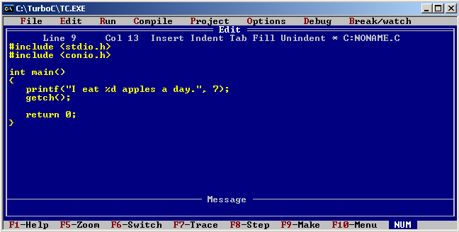

Save:

Press ALT + F > Save or F2.

Compile:

Press ALT + C > Compile to OBJ

Run :

Press ALT + R > Run or Ctrl + F9

Make EXE file:

Press ALT + C > Make EXE file

Use HELP:

Press F1.

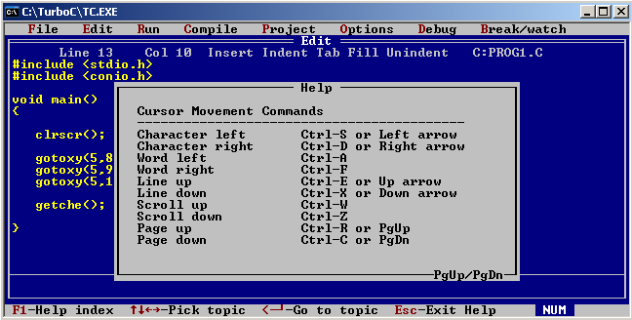

Navigate using PgUp or PgDn.

To use the HELP for a specific function, get the cursor near the function name and press CTRL + F1.

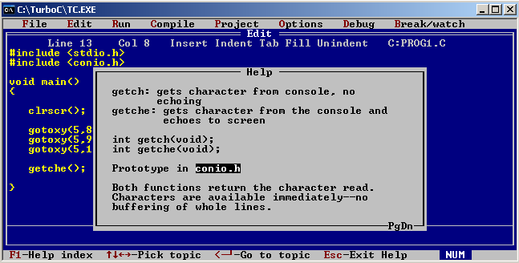

/----------------------------------------------------------------------------------------------------------------------------------------

Examine the code

#include <stdio.h>

#include <conio.h>

* This is your preprocessor directives. The preprocessor allows the ability to add header files to be able to use functions in the header files.

int main()

* The main function will always be the first function to be called in a program

{

printf(“I eat %d apples a day.”, 7);

getch();

* Body of the main function:
* Printf() stands for print formatted. %d or %i holds the format to print an integer value. In the code, 7 is the value.
* Getch() means get character. When the program is executed, it will halt and wait for a character input to continue the program.

return 0;

* Return 0 statement means a return value is needed when the function is ended. Notice that the function main has “int” before it. Int there is the data type of the function main. You may also change it to void(omit the return 0, void suggests that nothing is to be returned at the end of the function call), char(return a character), and lots more.

}

/----------------------------------------------------------------------------------------------------------------------------------------

Consider this code

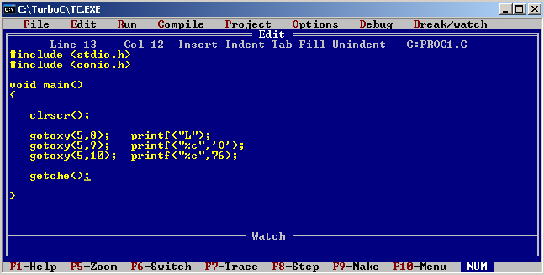

Clrscr() - clear screen

Gotoxy – go to coordinates x and y. The user screen is 80x25 starting at 1.

Getche() – get character with echo. Prints the character pressed by the user.

Enter user screen – ALT + F5

Assignment: Deadline is tomorrow November 5, 2013.

Read more about functions in C and Data Types.

Output:

Draw me 3 shapes of any area.

\*Use the first letter of your first name in printing the sides or curves.

\*The inside may or may not be filled with letters as long as a shape is seen on the user screen.

\*You may use loops.

\*You may color the printing of your letters.

Post your work.

<http://www.programmingsimplified.com/c/conio.h>